Order of jokes:

1.

Knock, knock. Who’s there? Olive. Olive, who? Olive you, and I don’t care who knows it.

2.

I'm not saying I hate you, but I would unplug your life support to charge my phone.

3.

Q: Can a kangaroo jump higher than the Empire State Building?  
A: Of course. The Empire State Building can't jump.

4.

It’s true that I’m CUTE: C(ringy), U(nattractive), T(rash), and E(asy to forget).

5.

What’s the difference between a G-spot and a golf ball? A man will actually search for a golf ball.

6.



7.



8.

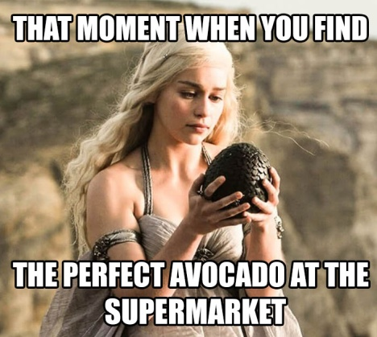

9.

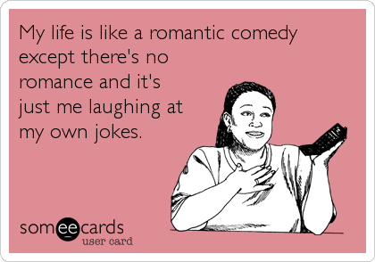

10.

